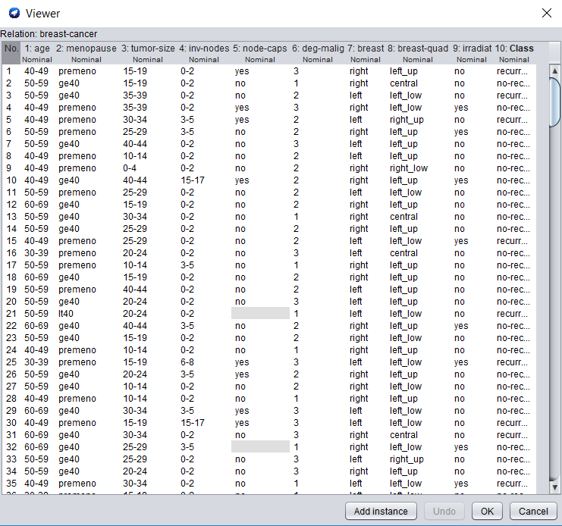

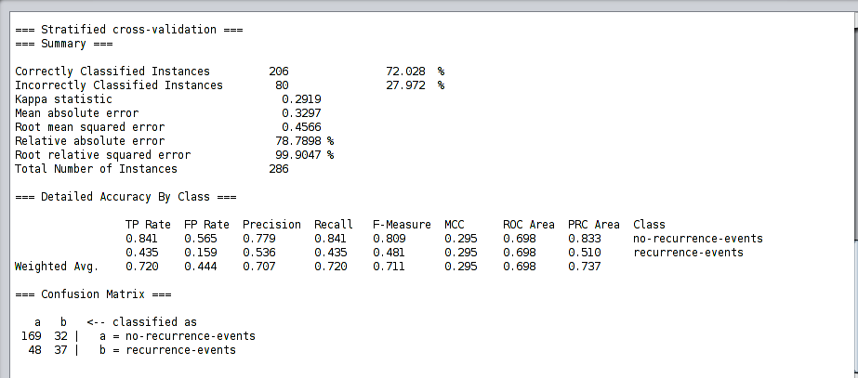**Breast Cancer Dataset**

**Naïve Baye’s Classifier**



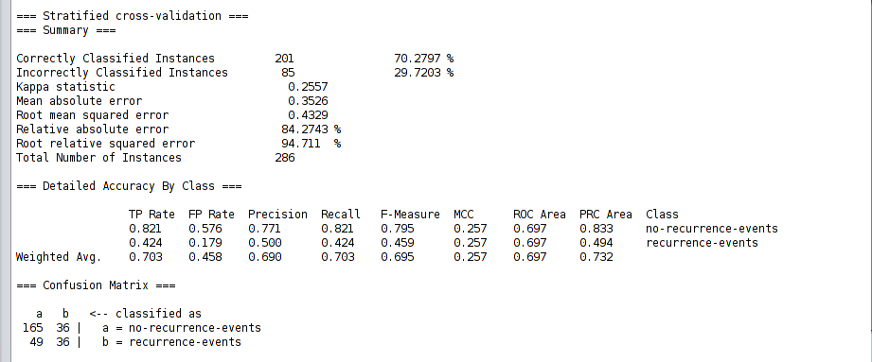**Breast Cancer Dataset**

**AdaboostM1**



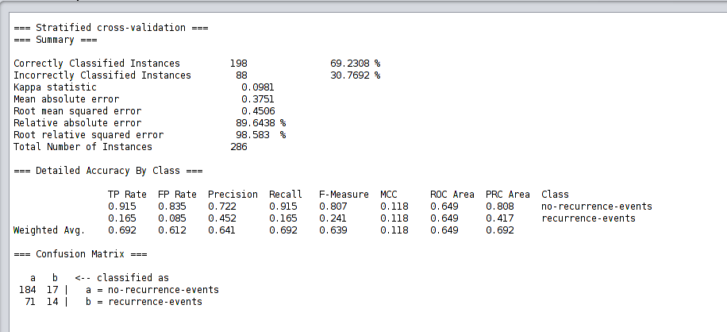**Breast Cancer Dataset**

**Bagging**



**Breast Cancer Dataset**

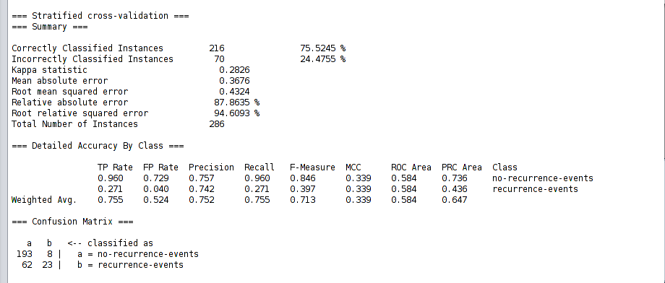

**J48 Classifier**



**Breast Cancer Dataset**

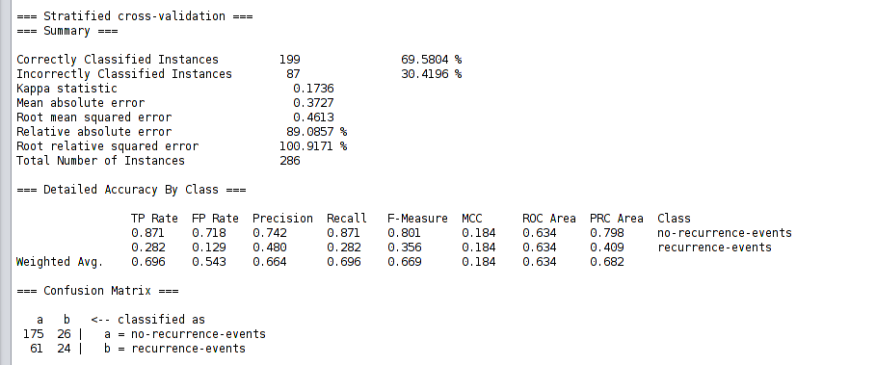

**Random Forest Classifier**